

**SPORT-CELEBRITY-IMAGE-CLASSIFICATION**

***Project submitted to the***

***S K Somaiya College, Somaiya Vidyavihar University For the partial fulfilment for the award of the degree of* Bachelor of Data Science**

***Submitted By***

**Name of the Student: Himansi Raval**

**Seat No. – __________**

**T.Y.B.Sc. Data Science Sem V**

**DEPARTMENT OF COMPUTER SCIENCE ACADEMIC YEAR 2023-2024**

***Under the Supervision of***

Faculty Name: _____________

DEPARTMENT OF COMPUTER SCIENCE

**CERTIFICATE OF AUTHENTICATION**

This is to certify that this Project is a work of “*Name of student” (Exam seat No.)* submitted to the S K Somaiya College in partial fulfilment of the requirement for the award of the degree of Bachelor of Data Science

I consider that the project has reached the standards and fulfilling the requirements of the rules and regulations relating to the nature of the degree. The contents embodied in the project have not been submitted for the award of any other degree or diploma in this or any other university.

**Date:**

**Place:**

(Name and Signature)

Faculty Incharge

(Name and Signature)

Coordinator:

**Declaration by the student**

**I certify that.**

a) The work contained in the thesis is original and has been done by myself under the supervision of my supervisor.

b) The work has not been submitted to any other Institute for any degree or diploma.

c) I have conformed to the norms and guidelines given in the Ethical Code of Conduct of the Institute.

d) Whenever I have used materials (data, theoretical analysis, and text) from other sources, I have given due credit to them by citing them in the text of the thesis and giving their details in the references.

e) Whenever I have quoted written materials from other sources and due credit is given to the sources by citing them.

f) From the plagiarism test, it is found that the similarity index of whole thesis is within 25%.

**Date:**

**Place:**

Signature

Name of the student with

Exam. Seat No.

Department of Computer Science

CERTIFICATE

This is to certify that Ms. ____________________________________________ bearing seat no. ______________________________ of Bachelor of Data Science (Third year Sem V), has satisfactorily completed the Project titled ____________________________________________ in the partial fulfilment for the award of the Bachelor of Data Science degree by the Somaiya Vidyavihar University, during the Academic year 2022-23.

Signature of the Faculty Incharge Signature of the Coordinator

Signature of the Examiner Signature of the HOD

Date of Examination College Seal

**Acknowledgement**

Write an acknowledgement for maximum of one page. The candidate should convey his appreciation to all whom have played a role for completion of his/her Project work. The supervisor, supervisor, head of the department, faculty members, lab mates etc may be acknowledged. Any controversial statement or non- academic/abused sentiments are not allowed to write in this page. At the end student should put his signature.

Name of the Student

**Table of Contents**

**You may have subsections like given in Chapter 1 for every chapter**

|  |  |  |
| --- | --- | --- |
| **Sr. No.** | **Contents** | **Page No.** |
| **Chapter 1** | **Introduction**  **1.1 Background of project**  **1.2 Problem Statement and Objectives of project**  **1.3 Purpose, Scope, and Applicability**  **1.4 Pros and Cons of Project** | 1 |
| **Chapter 2** | **Survey of Technologies**  **2.1 Hardware Requirement**  **2.2 Software Requirement** |  |
| **Chapter 3** | **Methodology and Algorithm**  **3.1 Method 1**  **3.2 Method 2** |  |
| **Chapter 4** | **Conclusion** |  |
| **Chapter 5** | **Future Enhancement** |  |
| **Chapter 6** | **Screen Shots** |  |
| **Chapter 7** | **Coding** |  |
| **Annexures** | **Bibliography** |  |
|  | **Web References** |  |

SPORT CELEBRITY IMAGE CLASSIFICATION

CHAPTER 1 Introduction:

Project Background

In the dynamic world of sports, athletes transcend the boundaries of competition to become cultural icons and inspirations to millions around the globe. With the proliferation of digital media and the omnipresence of images on various platforms, the need for efficient and accurate methods of classifying sports celebrity images has become increasingly vital. This task goes beyond mere recognition; it involves leveraging advanced technologies such as deep learning and image classification to automate the identification process.

Sports celebrities, with their distinctive features, poses, and iconic moments, present a unique challenge and opportunity for image classification. The ability to accurately identify and classify these athletes not only streamlines content management for media organizations but also enhances the user experience for fans seeking relevant and personalized content.

This research explores the realm of sport celebrity image classification, delving into the intersection of sports, technology, and artificial intelligence. By leveraging cutting-edge techniques in deep learning and computer vision, the goal is to develop a robust system capable of automatically recognizing and categorizing sports celebrities based on their visual attributes.

The significance of such a system extends beyond its immediate application in media and entertainment. It has the potential to impact areas such as sports analytics, fan engagement, and even athlete endorsement evaluations. As the sports industry continues to embrace technological advancements, the development of efficient image classification systems becomes pivotal for staying at the forefront of innovation.

This study will address the technical challenges involved in sport celebrity image classification, including variability in poses, lighting conditions, and image resolutions. It will also explore the ethical considerations associated with the use of such technology, such as privacy concerns and potential biases in the classification process.

As we embark on this journey into the fascinating intersection of sports and artificial intelligence, the ultimate aim is to contribute to the development of robust and responsible systems that enhance our ability to interact with and appreciate the captivating world of sports and its charismatic personalities.

Top of Form

**Purpose of Sports Celebrity Image Classification:**

1. **Content Management and Personalization:** The primary purpose of sports celebrity image classification is to streamline content management for media organizations. By automating the process of identifying and categorizing images of sports celebrities, media platforms can efficiently organize their content libraries, making it easier to retrieve and present relevant material. This, in turn, enhances the overall user experience for fans.

2. **Fan Engagement:** Sports celebrity image classification plays a crucial role in fan engagement. By accurately identifying athletes in images, platforms can deliver personalized content to fans based on their favorite athletes. This personalized approach strengthens the connection between fans and the sports personalities they admire, fostering a deeper level of engagement.

3. **Marketing and Endorsements:** For brands and marketers, the classification of sports celebrity images is valuable in the context of endorsements. By automating the identification of athletes in images, brands can assess the reach and impact of their sponsored athletes, ensuring that marketing efforts are targeted and effective.

4. **Sports Analytics:** In the realm of sports analytics, image classification can contribute to understanding player movements, expressions, and interactions during games. This data can be utilized for performance analysis, injury prevention, and strategic planning by coaches and sports analysts.

**Scope of Sports Celebrity Image Classification:**

1. **Multi-Sport Application:** The scope of sports celebrity image classification extends across various sports, encompassing athletes from disciplines such as football, basketball, soccer, tennis, and more. The system should be adaptable to the diverse physical characteristics and poses exhibited by athletes in different sports.

2. **Real-time Applications:** The scope includes real-time applications, such as live event coverage and social media updates. The ability to identify sports celebrities in real-time contributes to the immediacy and relevance of content delivery to fans.

3. **Cross-platform Integration:** The classification system's scope extends to integration with diverse platforms, including social media, sports apps, and news websites. This ensures a seamless experience for users across different digital spaces.

**Applications of Sports Celebrity Image Classification:**

1. **Media and Broadcasting:** Media organizations can use image classification to automate the tagging and categorization of sports celebrity images for archival purposes, making it easier to retrieve relevant content for broadcast or publication.

2. **Fan Apps and Platforms:** Sports apps and fan engagement platforms can leverage image classification to offer personalized content recommendations, updates, and highlights based on users' favorite athletes.

3. **Brand Monitoring:** Brands and marketing agencies can use image classification for monitoring the presence and impact of sponsored athletes in various media channels, helping them evaluate the effectiveness of endorsement deals.

4. **Sports Science and Analytics:** Sports teams and analysts can employ image classification for studying player movements, expressions, and interactions during games. This data can contribute to performance analysis, injury prevention, and strategic planning.

5. **Security and Authentication:** In exclusive events or restricted access areas, image classification can be employed for security purposes by identifying authorized personnel, athletes, and staff.

In summary, the purpose, scope, and applications of sports celebrity image classification are diverse, spanning from enhancing fan experiences to providing valuable insights for media, brands, and sports analytics. This technology's versatility makes it a valuable asset in the ever-evolving intersection of sports and technology.

**Pros of Sports Celebrity Image Classification:**

1. **Efficiency and Automation:**

- *Pro:* Image classification automates the process of identifying and categorizing sports celebrity images, significantly improving efficiency compared to manual methods.

- *Pro:* Quick and automated content management allows media organizations to focus more on content creation and delivery.

2. **Enhanced Fan Engagement:**

- *Pro:* Personalized content delivery based on recognized athletes fosters a deeper connection between fans and their favorite sports personalities.

- *Pro:* Fan engagement platforms can provide more relevant updates, highlights, and recommendations, enhancing the overall user experience.

3. **Marketing and Sponsorship Effectiveness:**

- *Pro:* Brands and marketers can assess the reach and impact of their sponsored athletes more accurately, ensuring a better return on investment in endorsement deals.

- *Pro:* Image classification aids in monitoring brand visibility during live events and in various media channels.

4. **Sports Analytics and Performance Analysis:**

- *Pro:* Sports teams and analysts can leverage image classification data for in-depth performance analysis, injury prevention, and strategic planning.

- *Pro:* Real-time insights into player movements and interactions contribute to a more comprehensive understanding of the game.

5. **Security and Authentication:**

- *Pro:* Image classification can be employed for security purposes, ensuring that only authorized personnel have access to restricted areas during events.

- *Pro:* Enhances event security by quickly identifying individuals and validating their credentials.

**Cons of Sports Celebrity Image Classification:**

1. **Privacy Concerns:**

- *Con:* There are inherent privacy concerns associated with the use of image classification, especially when it involves the identification of individuals in public or private settings.

- *Con:* Athletes may have concerns about the constant scrutiny and recognition in various contexts.

2. **Bias and Fairness:**

- *Con:* Image classification systems may exhibit biases based on factors such as race, gender, or physical appearance, leading to potential fairness issues.

- *Con:* Biases can result in misclassifications or under-representation of certain athletes.

3. **Technical Challenges:**

- *Con:* Variability in poses, lighting conditions, and image resolutions poses technical challenges for accurate and robust image classification.

- *Con:* Handling diverse sports and their unique characteristics may require ongoing refinement of algorithms.

4. **Ethical Considerations:**

- *Con:* The use of image classification technology raises ethical questions about consent, especially when applied to public figures who may not have explicitly agreed to being identified in various contexts.

- *Con:* Balancing technological advancements with ethical considerations is an ongoing challenge.

5. **Overreliance on Technology:**

- *Con:* Overreliance on image classification may lead to a reduction in human oversight, potentially overlooking nuances and context that a human observer might consider.

- *Con:* Blind trust in the technology may result in errors or misinterpretations.

6. **Resource Intensiveness:**

- *Con:* Implementing and maintaining sophisticated image classification systems can be resource-intensive, requiring significant computational power and ongoing updates.

Balancing the benefits of sports celebrity image classification with these potential drawbacks requires careful consideration, ethical guidelines, and continuous efforts to improve and address challenges. Responsible development and implementation are key to harnessing the positive impact of this technology while mitigating its limitations and risks.

CHAPTER 2 : Survey of Technologies

**Hardware Requirements:**

For the tasks you've mentioned, such as using Jupyter Notebook for Python-based development, Visual Studio Code (VSCode) for web development, and running a Flask server, the hardware requirements are generally modest. Here's a short note on the hardware requirements:

*No specialized hardware is required for these tasks.*

* **Processor:** A modern dual-core processor (or higher) should be sufficient for running development environments and servers.
* **RAM:** At least 8 GB of RAM is recommended, especially if you are working with large datasets or running multiple applications simultaneously.
* **Storage:** Adequate storage for your development projects. A solid-state drive (SSD) can enhance the overall performance of your system.

It's worth noting that these requirements are suitable for basic development and small to medium-sized projects. If you plan to work on larger datasets or more computationally intensive tasks, you might benefit from more powerful hardware.

**Software Requirements:**

1. **For Jupyter Notebook:**
   * **Python:** Ensure that you have Python installed on your system. You can use the Anaconda distribution, which includes Jupyter Notebook, or install Jupyter separately using pip.
   * **Libraries:** Install the necessary libraries like pywavelets, OpenCV, seaborn, and matplotlib using pip. For example:

Copy code

pip install pywavelets opencv-python seaborn matplotlib

1. **For VSCode (Visual Studio Code):**
   * **HTML, CSS, JS:** VSCode is a versatile code editor that supports a variety of languages, including HTML, CSS, and JavaScript. You can create HTML, CSS, and JS files directly in VSCode, and it provides features like IntelliSense for code completion.
   * **Extensions:** Consider installing extensions for web development to enhance your workflow.
2. **For Flask Server:**
   * **Flask:** Install Flask using pip:

Copy code

pip install Flask

* + **Additional Libraries:** Depending on your Flask application, you might need other libraries. Install them as required using pip.

These software requirements should be installed in their respective environments. You can use virtual environments to manage dependencies and isolate your project environments.

In summary, your laptop's general specifications should be sufficient for these tasks. Ensure that Python is installed, set up your development environment with the necessary libraries, and use VSCode for web development along with Flask for serving your applications.

**CHAPTER 3. METHODS AND ALGORITHM**

**DATA COLLECTION**

In the realm of supervised learning, the cornerstone of training a classifier lies in having an extensive repository of accurately label data. This dataset typically comprises images, denoted as the independent variable 'x,' and corresponding class labels, referred to as the target variable 'y.' These labels signify the identity or category to which each image belongs, exemplified by the likes of Messi, Maria Sharapova, or any designated classes.

The process of amassing this dataset necessitates a meticulous approach. The challenge involves acquiring a diverse array of images that comprehensively represent the distinct classes our classifier is intended to recognize. This curated dataset serves as the foundation upon which the classifier hones its ability to accurately categorize new, unseen images.

Effectively collecting such a dataset involves leveraging various sources and methodologies. These may include web scraping techniques to extract images from online repositories, collaborating with photographers or content creators to obtain specialized images, or utilizing existing public datasets. The aim is to ensure that the dataset encompasses a wide spectrum of scenarios and variations, enabling the classifier to generalize effectively and make accurate predictions across diverse inputs.

In essence, the robustness and efficacy of a supervised learning model hinge significantly on the quality and diversity of the training data. The meticulous curation of this dataset is a critical precursor to the subsequent stages of model training and evaluation, ultimately determining the classifier's ability to make informed and reliable predictions in real-world applications.

**There are four different ways of collecting this**

1. **Manual Download images from Google**

**While manually downloading images from Google for data collection can be a straightforward approach, it comes with several disadvantages and challenges:**

**a) Copyright and Licensing Issues:**

**- Images found on the internet may be subject to copyright restrictions and licensing agreements. Downloading and using such images without permission can lead to legal issues.**

**b) Quality and Consistency:**

**- The quality and resolution of images retrieved manually may vary significantly. Ensuring a consistent and high-quality dataset is challenging when collecting images from different sources.**

**c) Limited Quantity and Diversity:**

**- Depending on manual efforts alone may result in a limited dataset size and insufficient diversity. A robust model often requires a large and diverse dataset to generalize well to different scenarios.**

**d) Time-Consuming:**

**- Manually searching, downloading, and organizing images is a time-consuming process. It may not be practical for large-scale or time-sensitive projects.**

**e) Dependency on Search Queries:**

**- The effectiveness of manual collection depends on the specificity of search queries. Inaccurate or broad search terms may result in irrelevant or unrelated images being included in the dataset.**

**To mitigate these issues, it is advisable to complement manual collection with other methods, such as utilizing specialized datasets, obtaining permissions for image usage, and incorporating automated tools for more efficient and systematic data gathering. Additionally, thorough documentation of sources and adherence to ethical considerations are essential throughout the data collection process.**

1. Use Python and Web-Scrapping

While Python is a popular and versatile language for web scraping, there are some disadvantages and challenges associated with the practice. Here are some of them:

1. **Legal and Ethical Issues:**
   * **Terms of Service Violations:** Many websites have terms of service that explicitly prohibit web scraping. Scraping such websites without permission may lead to legal consequences.
   * **Ethical Concerns:** Even if scraping is technically allowed, it might be considered unethical, especially if it puts a strain on the target website's resources or if the data is used for malicious purposes.

.

1. **Website Changes:**
   * **Structure Changes:** Websites may undergo structural changes over time. If the structure of a website changes, your scraping script may break, and you'll need to update it accordingly.
   * **Data Format Changes:** If the format of the data on a website changes, your scraping script may no longer extract the information correctly.

**c)Data Quality and Reliability:**

* + **Incomplete Data:** Web scraping might not always guarantee complete or accurate data, especially if the website structure is complex or changes frequently.
  + **Rate Limiting:** Some websites implement rate limiting to restrict the number of requests from a single IP address within a given time frame, affecting the speed and reliability of scraping.

**d)Dependency on External Libraries:**

* + **Library Reliability:** Python has various libraries for web scraping, such as BeautifulSoup and Scrapy. Depending on these external libraries means you are subject to their development and maintenance cycles.

**e) Security Concerns:**

* + **Code Injection:** When scraping, you are often dealing with external data. If not handled carefully, it may expose your application to code injection attacks.
  + **Untrusted Sources:** Scraping data from untrusted sources can expose your system to security vulnerabilities.

It's crucial to be aware of these challenges and to approach web scraping with a thorough understanding of both the legal and technical aspects involved. Always ensure that you have the right to scrape a website and that your scraping practices are respectful of the target site's terms of service.

1. Buying Data from third party vendors

While buying data from third-party vendors can be a convenient way to acquire information, there are several disadvantages and risks associated with this practice. Here are some potential drawbacks:

a)Data Quality Issues:

Inaccuracies: Third-party data may not always be accurate or up-to-date. Errors in the data can lead to incorrect insights and decisions.

Incomplete Data: The data provided may lack certain key elements, leading to incomplete information and potentially affecting the usefulness of the dataset.

b) Data Privacy and Compliance:

Legal Compliance: Purchased data may not comply with data protection regulations such as GDPR or CCPA. Using non-compliant data can result in legal consequences for your organization.

Consent Issues: The data might have been collected without proper consent, raising ethical concerns and potential legal issues.

c) Dependency on External Sources:

Reliability of Vendors: Your data quality is dependent on the reliability and reputation of the third-party vendor. If the vendor is not reputable or goes out of business, it can impact your access to the data.

d) Security Risks:

Data Breaches: Depending on the security measures of the third-party vendor, there may be a risk of data breaches. If the vendor's systems are compromised, the data you purchased could be exposed.

e) Cost Considerations:

Expense: Acquiring data from third-party vendors can be expensive, especially for high-quality and specialized datasets. The cost may not always justify the value received, and budget constraints can be a limiting factor.

f) Limited Control:

No Control Over Collection Methods: You have no control over how the data was collected and processed by the third-party vendor. This lack of control can be a concern, especially if transparency is crucial for your organization.

Before purchasing data from third-party vendors, it's essential to thoroughly vet the vendor, understand the terms of data usage, and ensure compliance with relevant data protection laws. Additionally, assess the quality and relevance of the data to determine its suitability for your specific business needs.

Top of Form

1. Fatkun Chrome Extension

Fatkun Batch Download Image is a Chrome extension designed to simplify the process of downloading images from web pages. Keep in mind that the features and capabilities of browser extensions can evolve, so it's a good idea to check the latest information or reviews for the most accurate details. Here are some potential advantages of using the Fatkun Chrome extension:

a) Ease of Use

- Fatkun is designed to be user-friendly, providing a simple and intuitive interface. Users can easily initiate the image download process with just a few clicks.

b) Batch Downloading:

- The extension allows users to download multiple images at once, streamlining the process for individuals who need to save or collect a large number of images from a webpage.

c) Customizable Options:

- Depending on the version and settings, Fatkun may offer customizable options, such as specifying the types of images to download, setting download destinations, and configuring other preferences.

d) Time Efficiency:

- Batch downloading can save time compared to manually downloading each image separately. This is particularly useful when dealing with web pages that contain numerous images.

e) Works Within the Browser:

- Being a Chrome extension, Fatkun integrates directly into the Chrome browser, making it a convenient tool for users who spend a significant amount of time using Chrome for web browsing.

f) Free to Use:

Extensions like Fatkun are often available for free, providing users with a cost-effective solution for their image downloading needs.

It's important to note that while these advantages may make Fatkun a useful tool for certain users, the overall effectiveness of the extension can depend on factors such as the specific website you're downloading images from and the extension's compatibility with the website's structure.

Additionally, when using browser extensions, it's crucial to consider security and privacy. Only install extensions from reputable sources, and be mindful of the permissions you grant to extensions to ensure the safety of your browsing experience. Always check user reviews and update your extensions regularly to benefit from any improvements or security patches.

STEPS FOR PERFORMING DATA COLLECTION

Step 1 :- Search on Google “ Fatkun chrome extension “



Step2 :- Add this “Fatkun Batch Download Image “ extension to your chrome

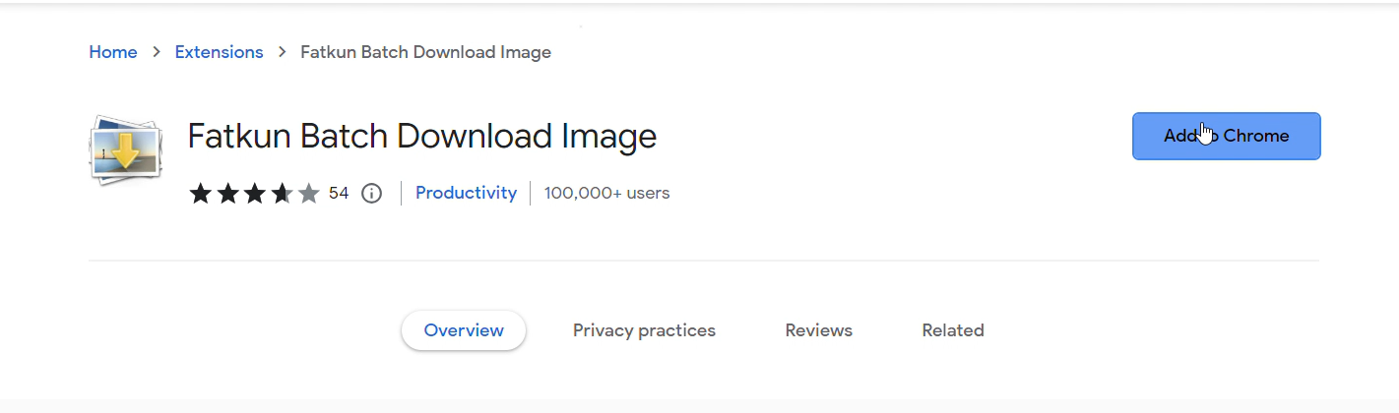

Step3 :- Search sports celebrity ‘s name on Google and Download it easily with the help of Faatkun chrome tool

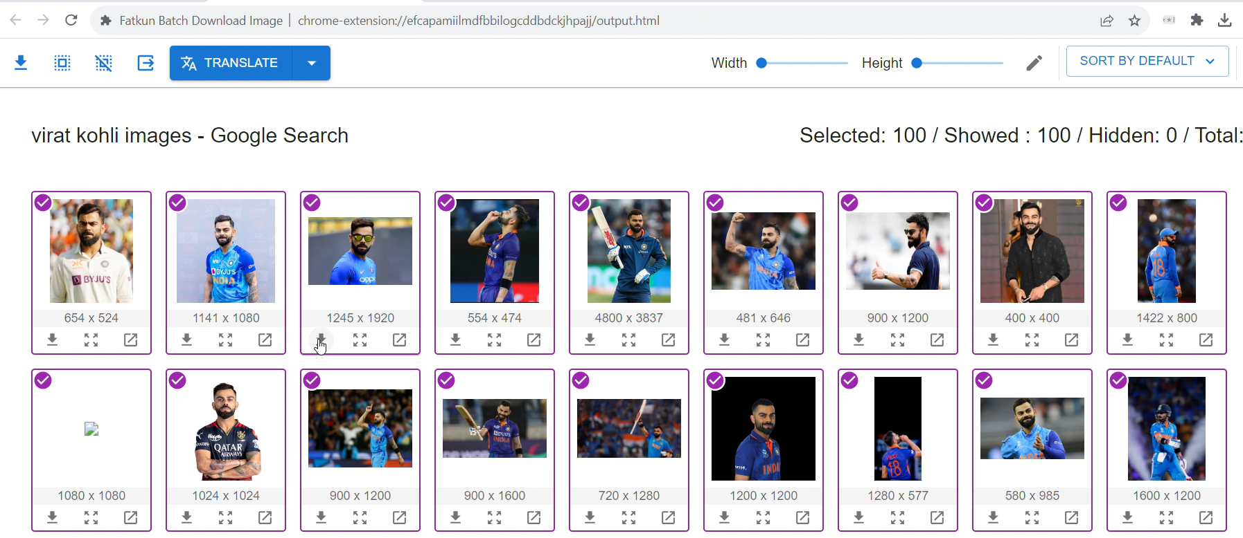

Step4 :- Store it in a folder

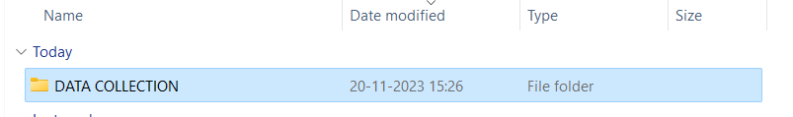

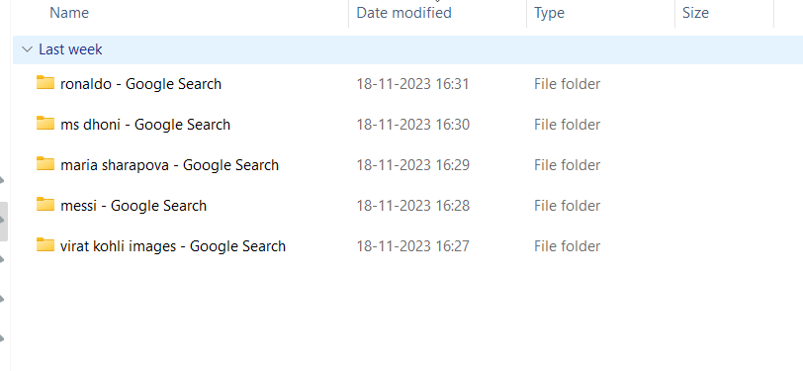

**DATA CLEANING**

Data collection is the process of gathering and measuring information on variables of interest, often in a systematic and organized manner. This information can be collected for various purposes, such as research, analysis, decision-making, or monitoring

When we download our images from the internet the images might have a lot of issues When we want to detect a person from that image How would you go detecting that person is a X or Y , Majority of the time you will be using the face of a person now using the Hands and Legs We tell about a person at some extent but your final decision of who that person is mostly based on the face and We are going to use the same concept on all the images that we downloaded from Google will first try to detect the face of the person sometimes face might be off start obstructed so we want to detect if the face is clearly visible or not now How do you detect that So we will try to detect two eyes as well so if in a photo you can find a face wit two eyes clearly then we will keep that image otherwise we will discard it For Face detection and detecting the eyes we will be using OpenCV which is famous image processing library in the python and for the specific detection we will be using a technique called haar cascade that’s a famous technique on how you can detect the face and the two eyes

HAAR CASCADE

Haar cascade is a machine learning object detection method used to identify objects or patterns in images or video. It employs a series of simple rectangular filters (Haar-like features) to analyze regions of an image at different scales. These features are trained on positive and negative samples to distinguish between the object of interest and the background. The classifier is then cascaded, with each stage refining the detection by eliminating false positives. This efficient approach allows for real-time object detection and has been widely used in applications like face detection in computer vision.

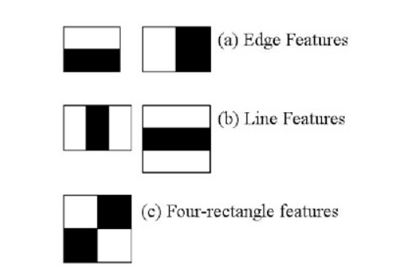

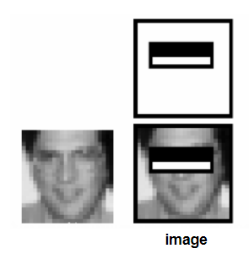

Before Writing Code, we need to install some packages

PyWavelets

Opencv-python

Seaborn

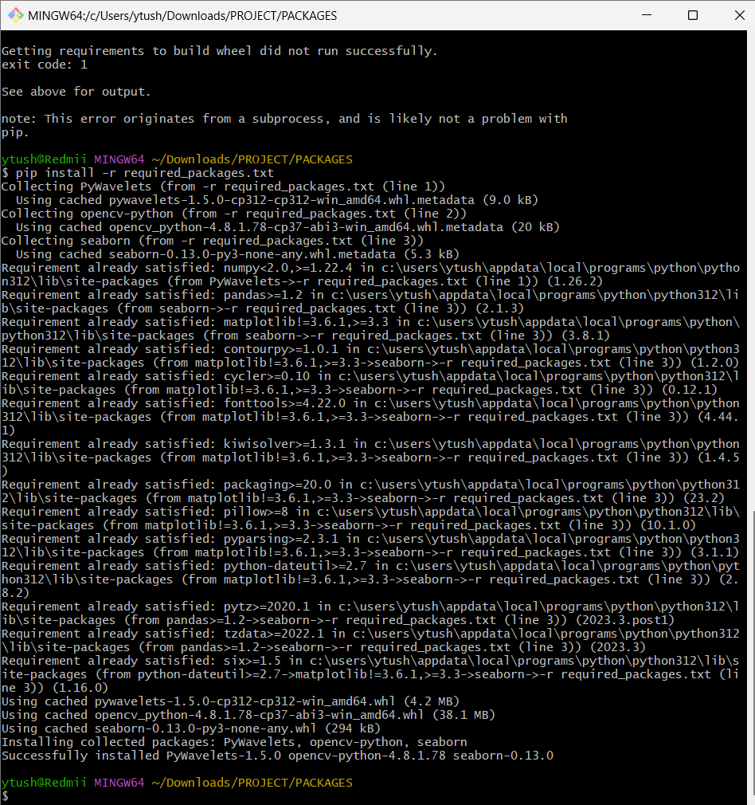

A SAMPLE DATA CLEANING

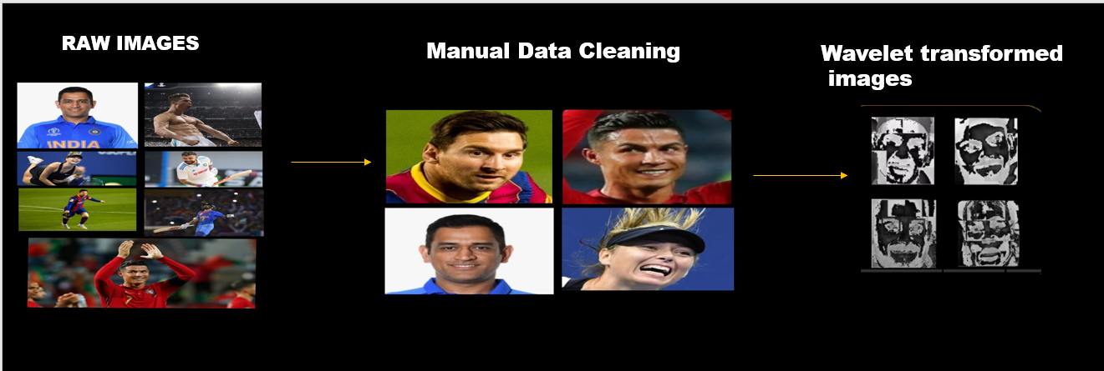

WAVELET TRANFORMATION

Wavelet transformation is a mathematical technique used in signal processing and image analysis for analyzing and representing signals or images in terms of wavelets. Unlike traditional Fourier transforms that use sinusoidal basis functions, wavelet transforms use wavelets, which are small, localized waves with finite duration. This allows wavelet transforms to capture both high and low-frequency components of a signal or image with excellent time and frequency localization.

There are two main types of wavelet transforms: Continuous Wavelet Transform (CWT) and Discrete Wavelet Transform (DWT).

1. **Continuous Wavelet Transform (CWT):**
   * The CWT is used for continuous signals and involves the convolution of the signal with scaled and shifted versions of the continuous wavelet function.
   * The continuous wavelet transform is expressed mathematically as: ���(�;�,�)=∫−∞∞�(�)�(�−��)��*CWT*(*f*;*a*,*b*)=∫−∞∞​*f*(*t*)*ψ*(*at*−*b*​)*dt* where �(�)*f*(*t*) is the signal, �*ψ* is the continuous wavelet function, �*a* is the scale parameter, and �*b* is the translation parameter.
2. **Discrete Wavelet Transform (DWT):**
   * The DWT is used for discrete, sampled signals, such as digital images or time-series data.
   * It involves a series of high-pass and low-pass filters applied to the signal to obtain approximation coefficients (low-frequency components) and detail coefficients (high-frequency components) at different scales.
   * The DWT is often implemented using a filter bank, and it is a key component in various image and signal processing applications.

Wavelet transformation has several applications:

* **Image Compression:** Wavelet transforms are commonly used in image compression techniques, such as JPEG2000. They provide a good compromise between spatial and frequency information, allowing for efficient compression.
* **Signal Denoising:** The ability of wavelet transforms to represent signals in both time and frequency domains makes them effective in denoising applications. High-frequency components, often associated with noise, can be easily separated and filtered.
* **Feature Extraction:** In image processing, wavelet transforms are used for feature extraction. They can highlight edges and other important features at different scales.
* **Biomedical Signal Analysis:** Wavelet transforms are employed in the analysis of biomedical signals, such as electrocardiograms (ECG) and electroencephalograms (EEG), for detecting abnormalities or patterns.
* **Audio Signal Processing:** Wavelet transforms find applications in audio signal processing, including compression and denoising in audio files.

Wavelet transforms offer a powerful and flexible tool for analyzing signals and images, providing a localized and multi-resolution representation that is well-suited for a variety of applications in diverse fields.

SUPPORT VECTOR MACHINE

Support Vector Machines (SVM) is a supervised machine learning algorithm used for classification and regression tasks. Developed by Vapnik and Cortes in the 1990s, SVM has gained popularity for its effectiveness in handling high-dimensional data and its ability to perform well in both linear and non-linear scenarios.

### Key Concepts:

1. **Hyperplane:**
   * In a binary classification problem, SVM aims to find a hyperplane that best separates the data into two classes. A hyperplane is a decision boundary that maximizes the margin between the classes.
   * For a two-dimensional space, a hyperplane is a line; in three dimensions, it's a plane, and so on. The goal is to find the hyperplane with the maximum margin, i.e., the maximum distance between the hyperplane and the nearest data point of each class.
2. **Support Vectors:**
   * Support vectors are the data points that lie closest to the hyperplane. These are the critical points that determine the position and orientation of the hyperplane.
   * The SVM algorithm is named after these support vectors because they "support" or define the optimal hyperplane.
3. **Margin:**
   * The margin is the distance between the hyperplane and the nearest data point of either class. SVM aims to maximize this margin, providing robustness to the model.
   * Larger margins often lead to better generalization performance on unseen data.
4. **Kernel Trick:**
   * SVM can efficiently handle non-linear decision boundaries through a technique called the "kernel trick." Kernels transform the input data into a higher-dimensional space, making it possible to find a hyperplane that separates the data in this transformed space.
   * Common kernels include linear, polynomial, radial basis function (RBF), and sigmoid.

### SVM Training:

1. **Objective Function:**
   * SVM formulates the problem as an optimization task, aiming to maximize the margin while minimizing the classification error.
   * The objective function involves both maximizing the margin and minimizing a regularization term that penalizes misclassified data points.
2. **Soft Margin SVM:**
   * In real-world scenarios, the data may not be perfectly separable. Soft Margin SVM introduces the concept of allowing some data points to be misclassified, introducing a penalty for misclassifications.

### SVM Classification:

Once trained, the SVM classifies new data points by determining which side of the hyperplane they fall on.

### Advantages of SVM:

1. **Effective in High-Dimensional Spaces:** SVM works well in high-dimensional spaces, making it suitable for tasks with a large number of features.
2. **Versatility with Kernels:** The kernel trick allows SVM to handle non-linear decision boundaries and complex relationships between features.
3. **Robust to Overfitting:** SVM is less prone to overfitting, especially in high-dimensional spaces.
4. **Global Optimum:** SVM optimization involves convex optimization problems, ensuring that the algorithm converges to a global optimum.

### Limitations of SVM:

1. **Sensitivity to Noise:** SVM is sensitive to noise in the data, and outliers can significantly impact the performance.
2. **Computational Intensity:** Training an SVM can be computationally intensive, particularly when dealing with large datasets.
3. **Interpretability:** The decision function learned by SVM might be challenging to interpret, especially in high-dimensional spaces.

SVM is a powerful algorithm with widespread applications in classification, regression, and outlier detection. Its ability to handle complex relationships and high-dimensional data makes it a valuable tool in the machine learning toolbox.

FLASK SERVER

Flask is a lightweight and flexible web framework for Python that allows developers to build web applications quickly and easily. A Flask server refers to the web server that runs a Flask application, handling incoming requests from clients (typically web browsers) and returning the appropriate responses.

### Key Concepts in a Flask Server:

1. **Routing:**

- In Flask, routing is the process of mapping URLs to specific functions (view functions) in your Python code. Routes define the entry points for different parts of your application.

- Example:

```python

from flask import Flask

app = Flask(__name__)

@app.route('/')

def home():

return 'Hello, this is the home page!'

```

2. **View Functions:**

- View functions are Python functions that handle requests to specific routes. They process the incoming request, perform any necessary actions, and return an HTTP response.

- Example:

```python

@app.route('/about')

def about():

return 'This is the about page.'

```

3. **Templates:**

- Flask supports the use of templates, typically using the Jinja2 template engine. Templates allow you to separate the HTML structure from the Python code, making it easier to manage and maintain.

- Example:

```python

from flask import render_template

@app.route('/user/<username>')

def user_profile(username):

return render_template('profile.html', username=username)

```

4. **HTTP Methods:**

- Routes in Flask can be associated with specific HTTP methods (e.g., GET, POST, etc.). This allows you to handle different types of requests differently.

- Example:

```python

@app.route('/login', methods=['GET', 'POST'])

def login():

if request.method == 'POST':

# Handle login form submission

else:

# Display login form

```

5. **Request and Response Objects:**

- Flask provides request and response objects to handle incoming requests and generate responses.

- Example:

```python

from flask import request

@app.route('/greet', methods=['POST'])

def greet():

data = request.get_json()

name = data.get('name', 'Guest')

return f'Hello, {name}!'

```

6. **Static Files:**

- Flask allows you to serve static files (e.g., CSS, JavaScript, images) directly from the server.

- Example:

```python

# Assuming 'static' is a folder in your project directory

# You can link to a CSS file in your HTML templates like this:

# <link rel="stylesheet" href="{{ url_for('static', filename='style.css') }}">

```

### Running a Flask Server:

To run a Flask server, you typically execute your Flask application script, and Flask will start a development server. Example:

```python

if __name__ == '__main__':

app.run(debug=True)

```

The `debug=True` parameter enables the development mode, providing helpful error messages and automatically restarting the server on code changes.

### Deployment:

For production, it's recommended to use a production-ready server, such as Gunicorn or uWSGI, in conjunction with a web server like Nginx or Apache. This setup improves performance and security.

Flask is a versatile and beginner-friendly framework, making it suitable for small to medium-sized web applications and APIs. However, for large-scale applications, additional considerations and configurations may be necessary for optimal performance and security.